1. **League is in its current annual average for draws above the 8-year average by 1 percentage point**
   1. As I understand this function will update to old tool
   2. Step by step will be :

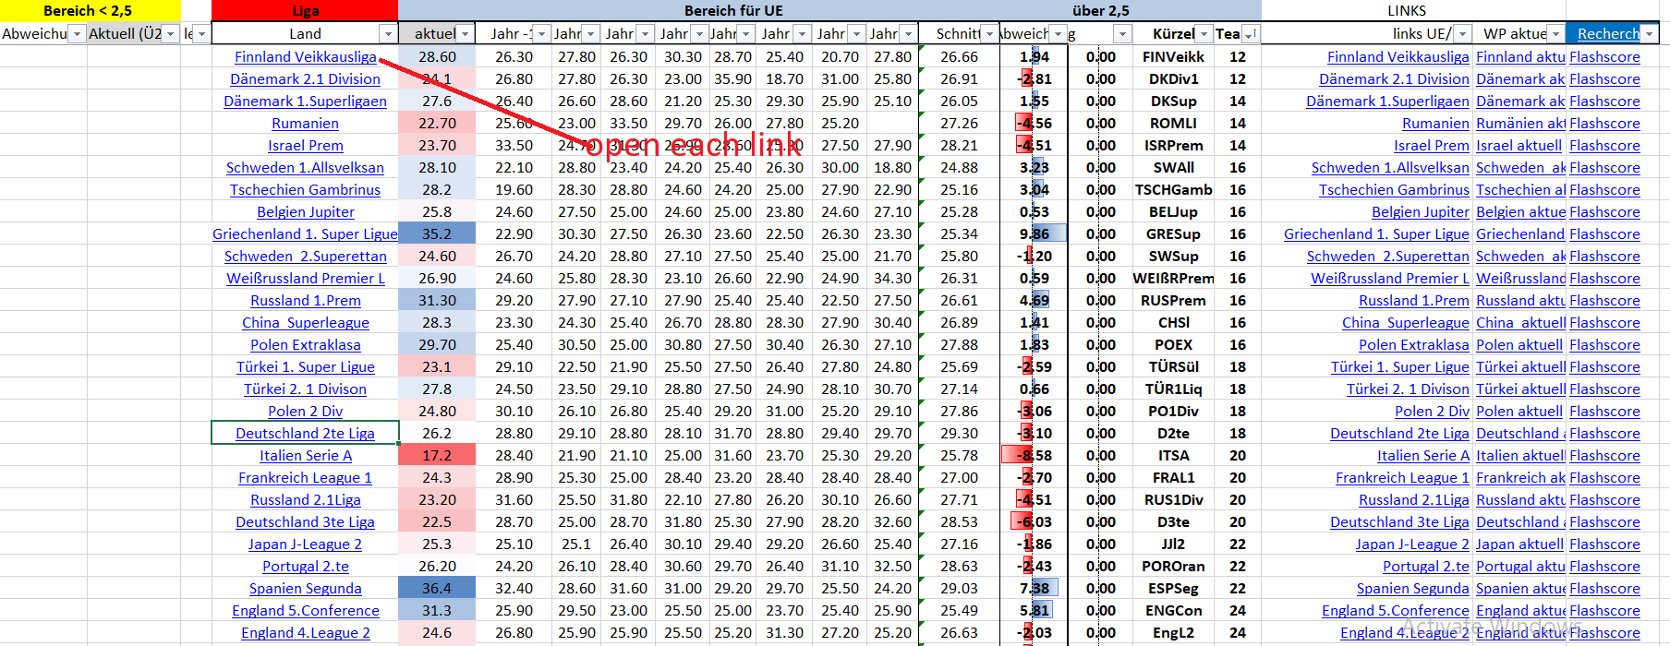

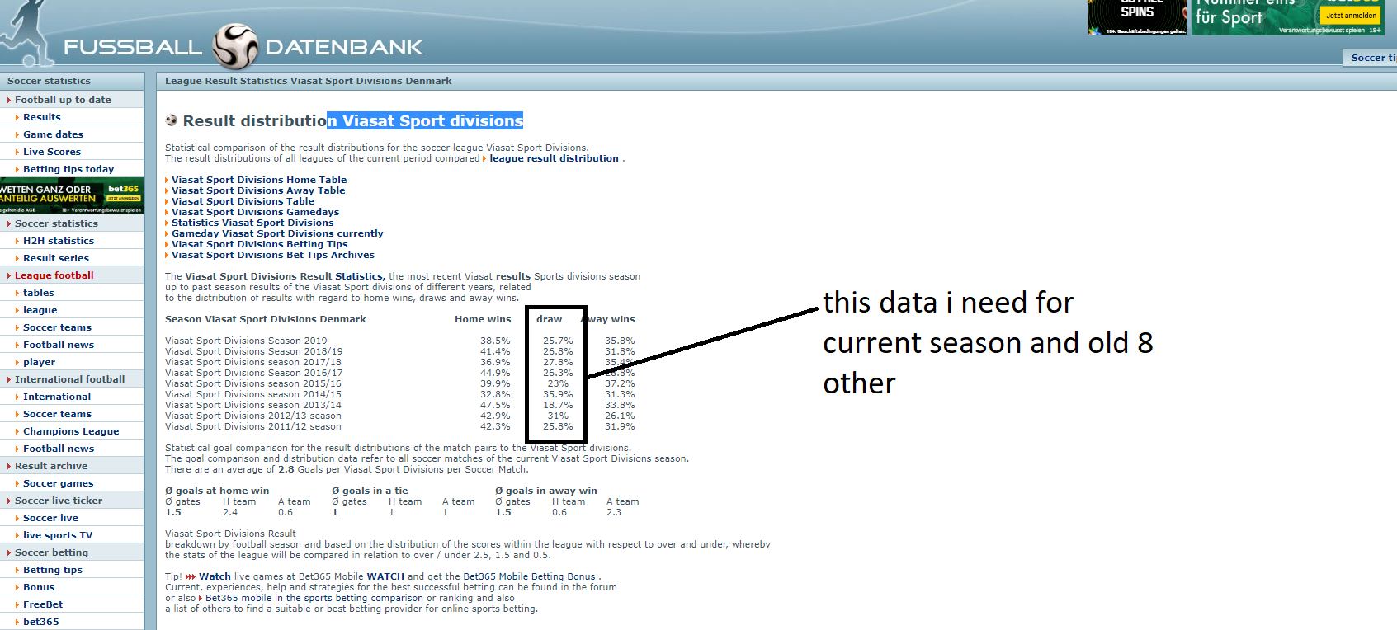

For this example I will get value to “Transfer difference from current value to 8 annual average to result” so it will be respectively -1,1%, -2,1%, -0,6%, 2,7%, -10,2%, 7%, -5,3%, -0,1%

* Were I can show value in excel and show to show ( show all in one new column or each value in each column)

1. **Distance between the two teams in points is less than or equal to 5**
   1. Step by step will be

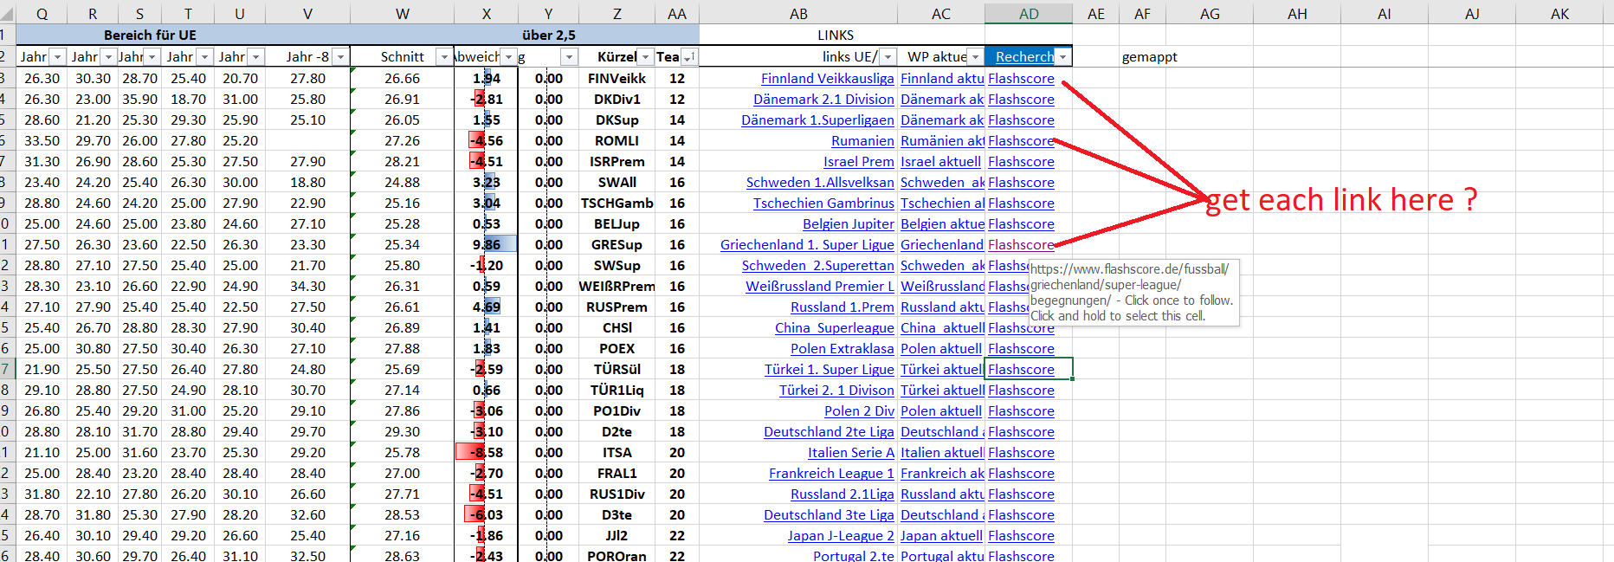

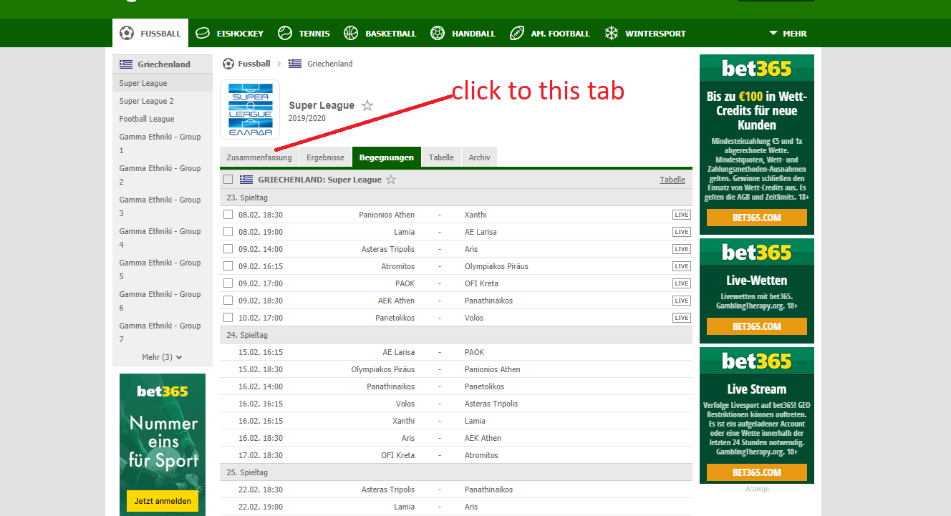

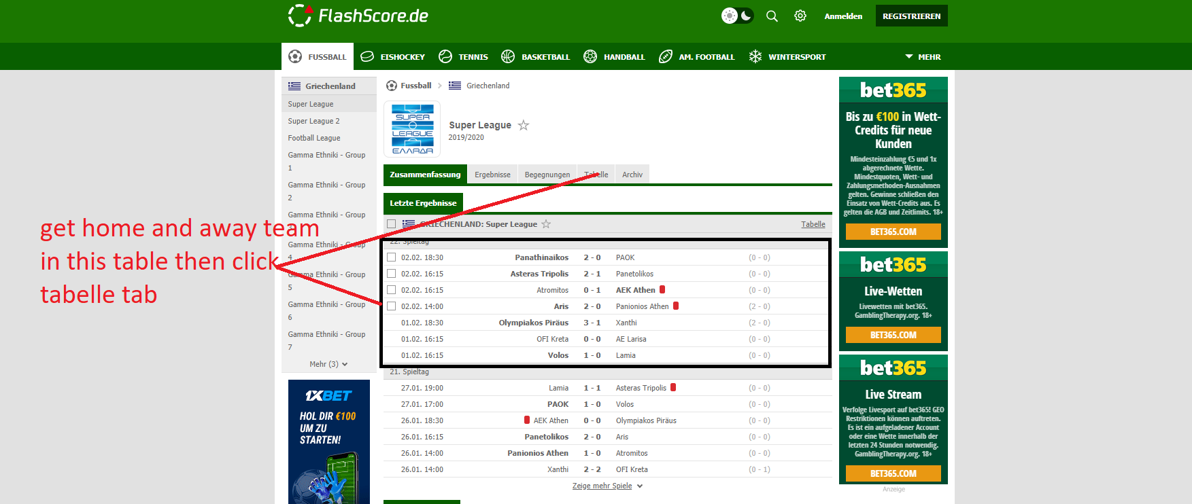

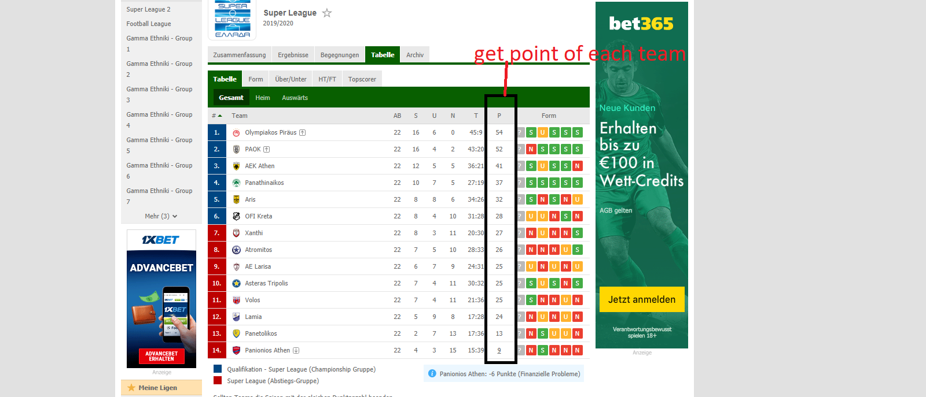

* calculation: points of the home team - points of the away team
* Transfer result of the calculation will write to column “**Punkteabstand”**
* That follow is correct ?

1. **The number of draws in the last 10 matches (10 last matches home team and 10 last matches away team)**
   1. Step by step will be :





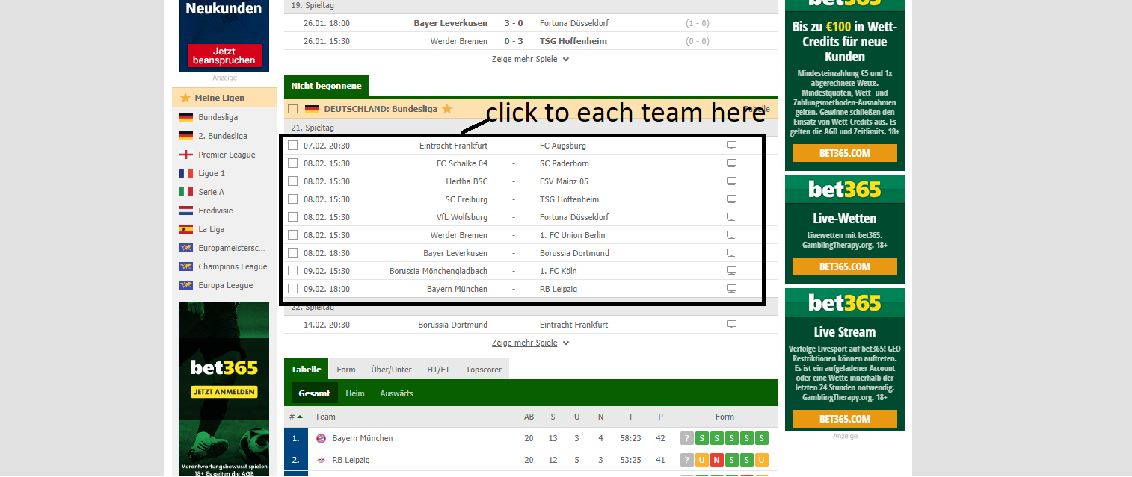

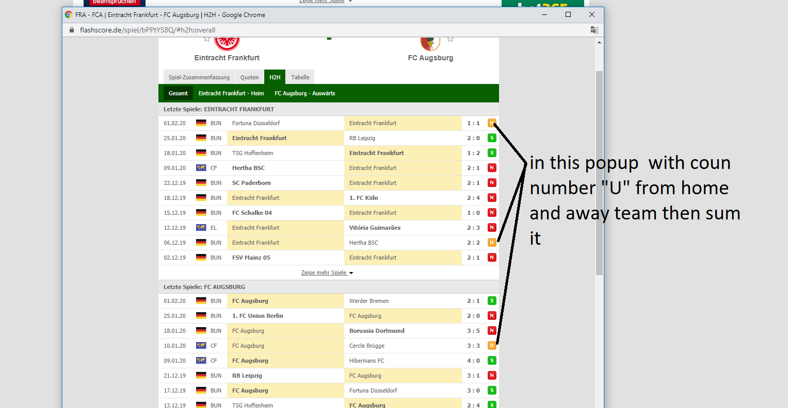

* The result data will write to column “**Anzahl UE** ”
* This follow is correct ?
* And one other question please see in picture above

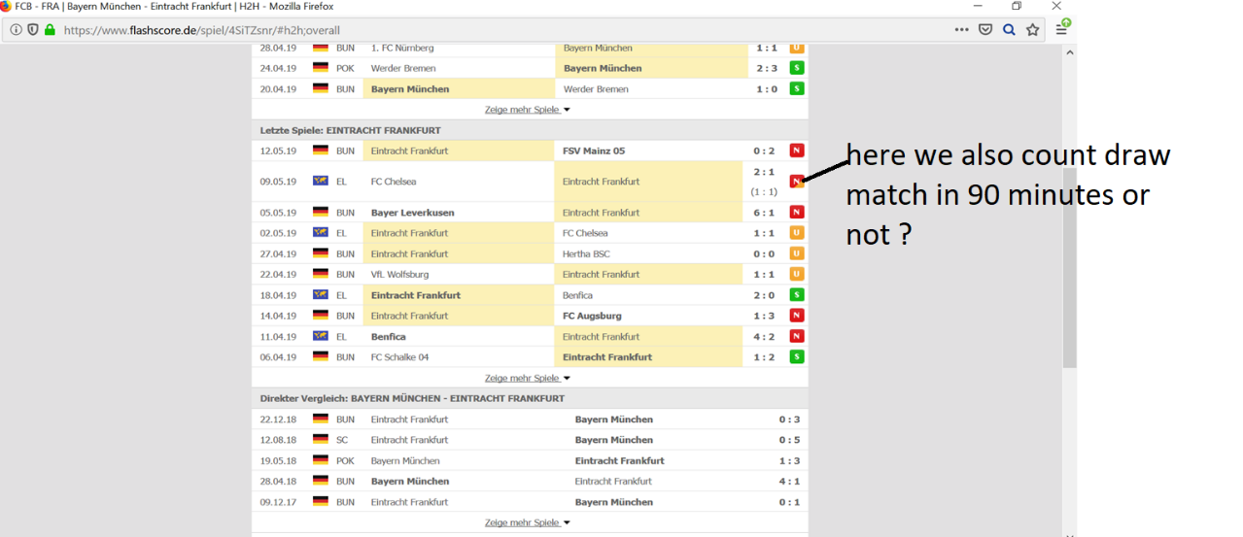

1. **Odds for home win (1), draw (X) and away win (difference between home win quota and away win quota maximum 2)**
   1. Step by step will be :

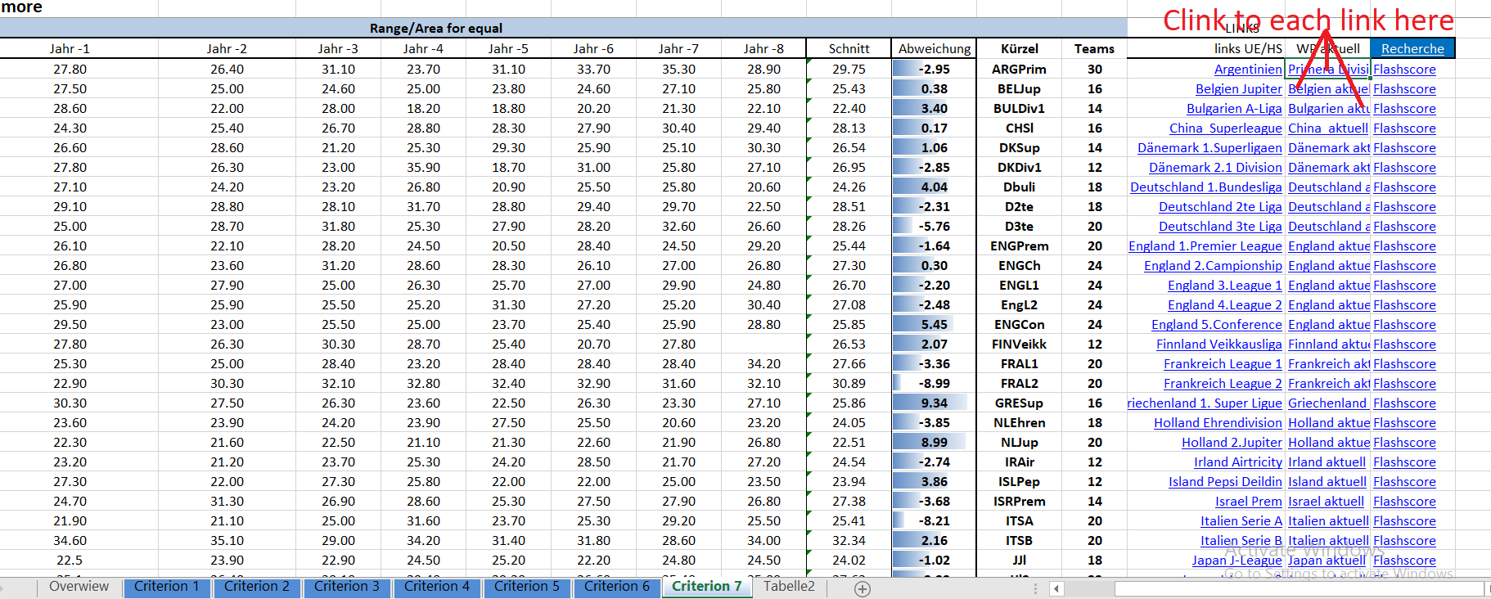

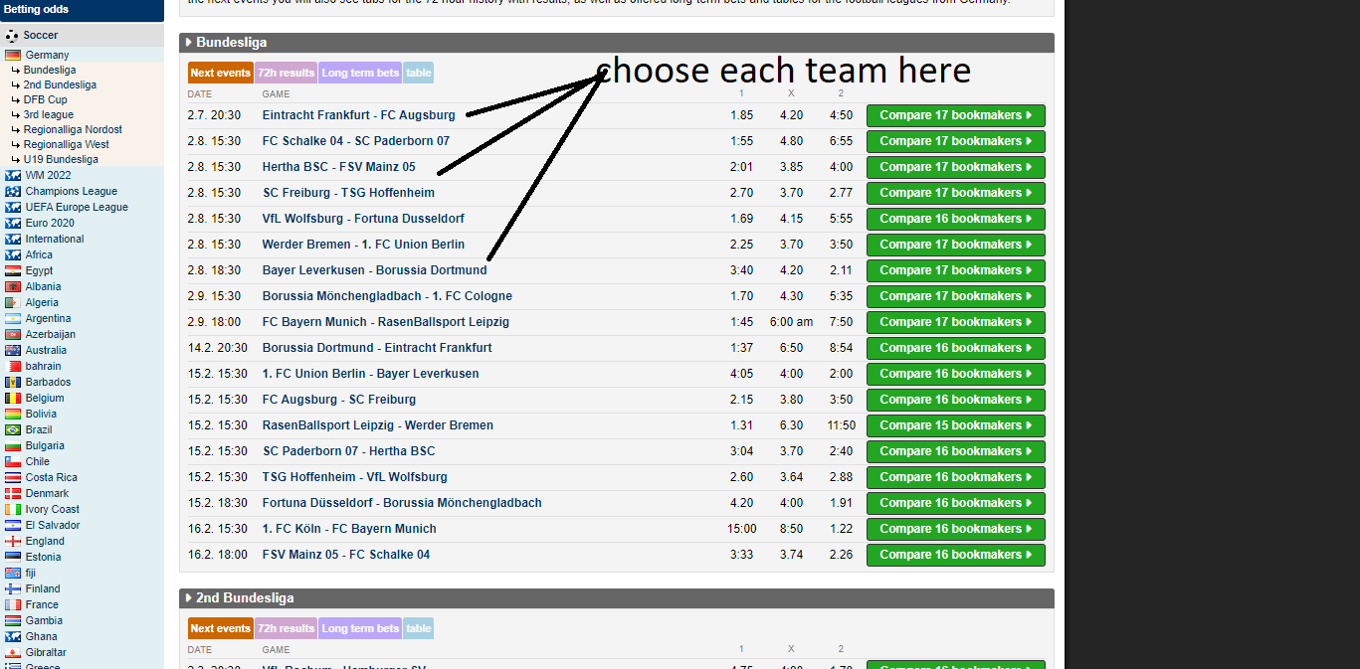

* selected line contains the desired values for 1/X/2 then get difference home win to away win maximum 2 >> please help me clear how I can get data here, I really don’t understand this table

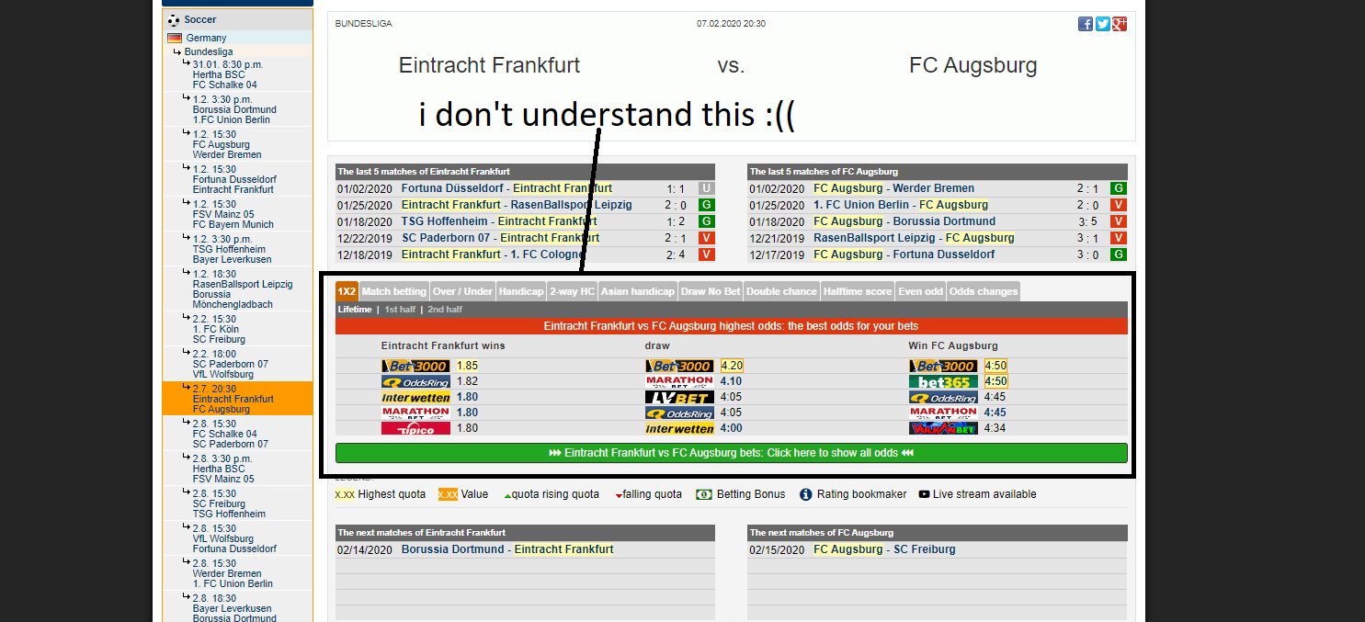

* Transfer corresponding values for odds home win/opportunity undecided/opportunity away win to result >> what name of column I will write value data to it ?

1. **The quota for over 1.5 goals is**
   1. Step by step will be:





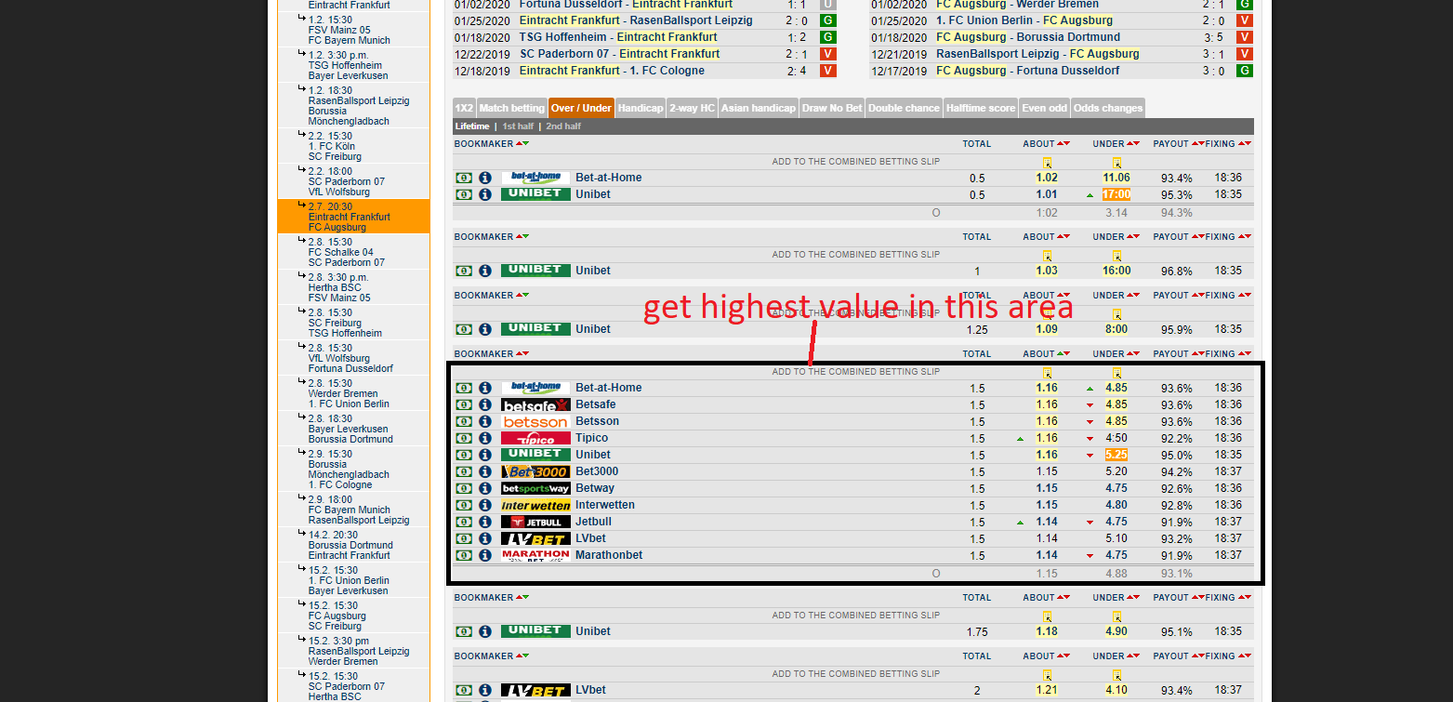

* Write highest value to “**über 1,5**“
* This follow is correct ?

1. **The quota for over 2.5 goals is**
   1. Step by step will be same with 1,5 but get highest value in 2.5 area the write value to “**über 2,5**”

`* another question : the total match in Flashscore and Wettportal maybe different in the league, so we will get maximum match we have ? (see in picture below)

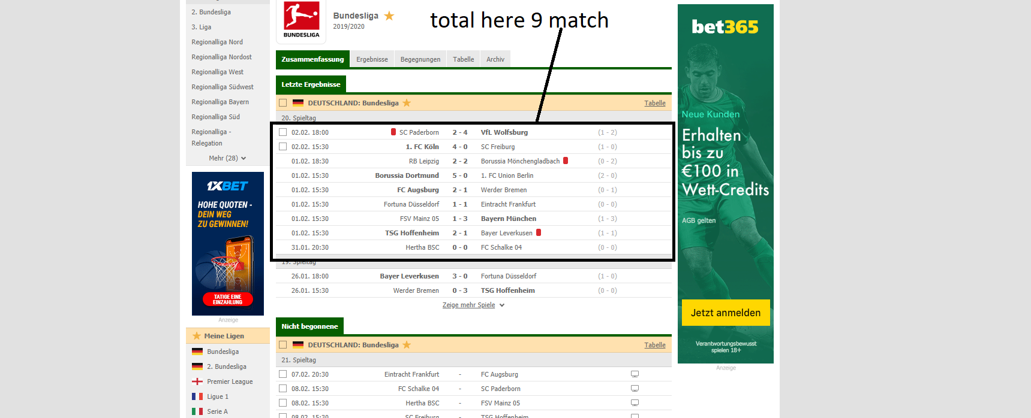

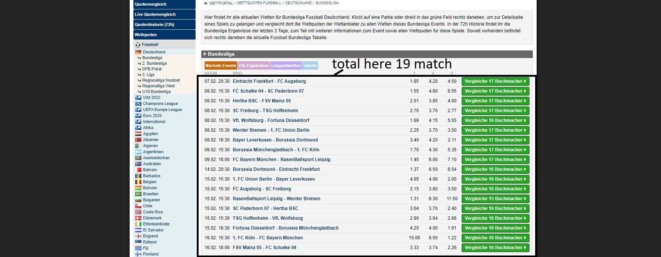

In the wettportal is total started march and not started march ?